AI Assisted Coding
Assignment - 5
Name: I.Harshith
Ht.No: 2303A51624
Batch:- 08
Task Description #1 (Privacy in API Usage)
Task: Use an AI tool to generate a Python program that connects to a weather API. Code:
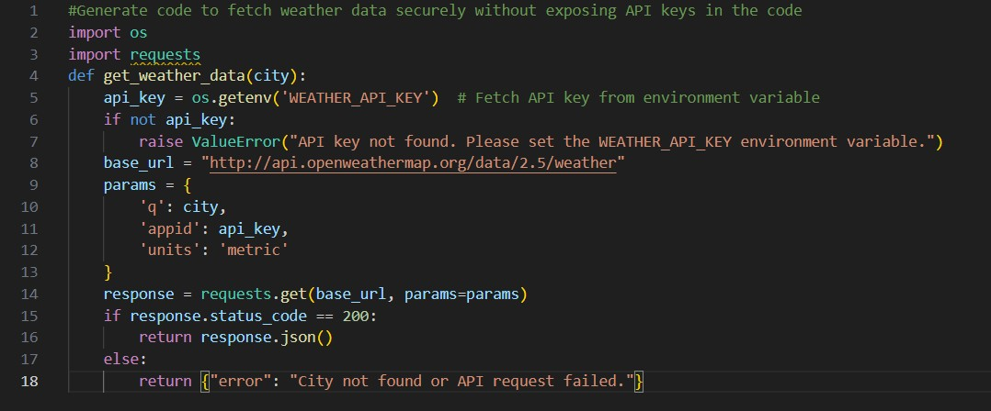
Task Description #2 (Privacy & Security in File Handling)
Task: Use an AI tool to generate a Python script that stores user data (name, email, password) in a file.
Analyze: Check if the AI stores sensitive data in plain text or without encryption.
Code:
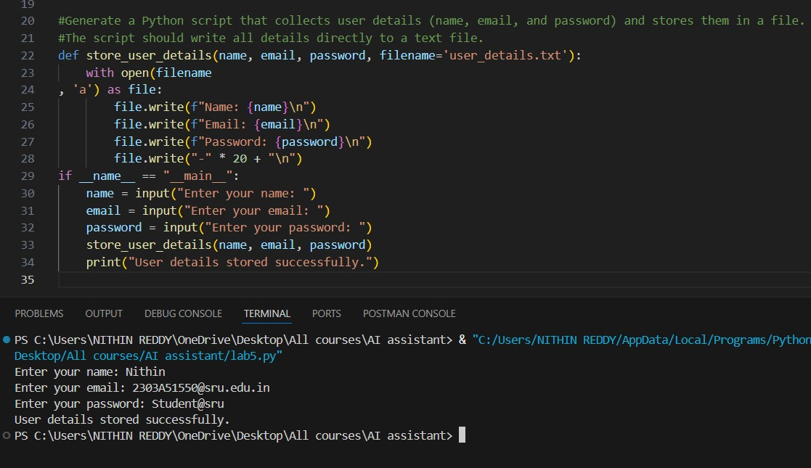
Task Description #3 (Transparency in Algorithm Design)
Objective: Use AI to generate an Armstrong number checking function with comments and explanations. Code:
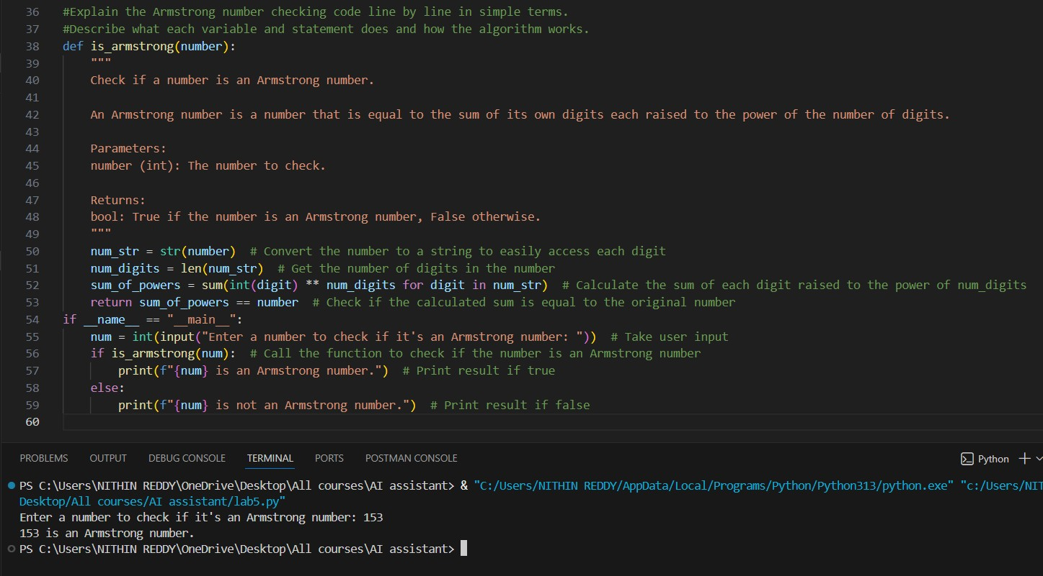

Task Description #4 (Transparency in Algorithm Comparison) Task: Use AI to implement two sorting algorithms (e.g., QuickSort and BubbleSort). Code:
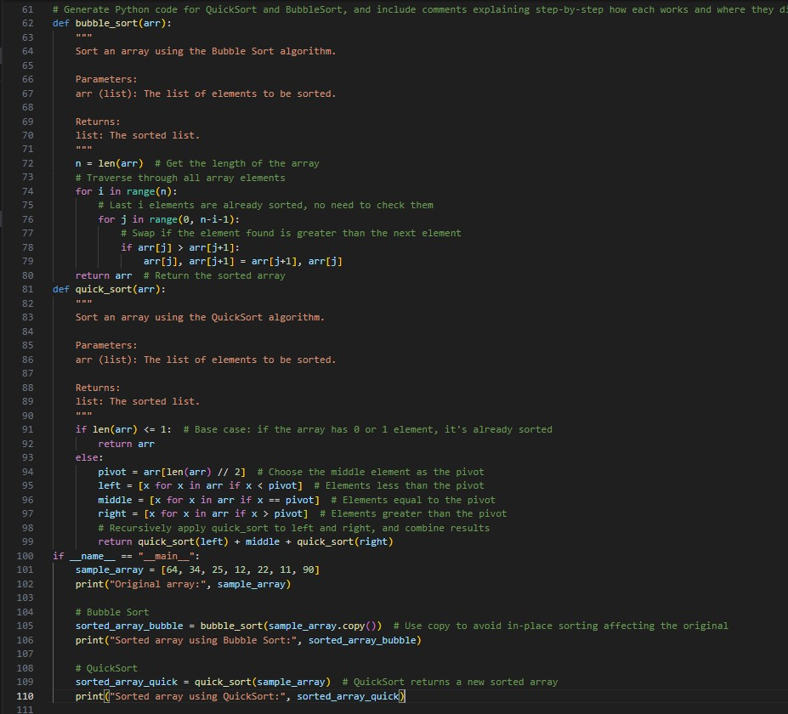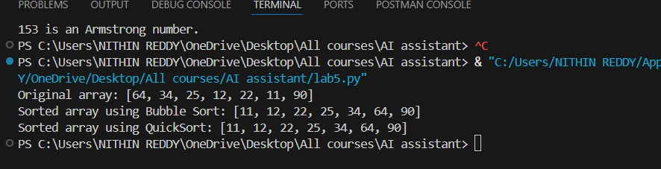

Task Description #5 (Transparency in AI Recommendations) Task: Use AI to create a product recommendation system. Code:
